Public Docker Registry - dockerhub
ajeetkumarv
ajeetkumarv7@gmail.com

Tutorial https://www.youtube.com/watch?v=fqMOX6JJhGo&t=2172s

sample commands
docker run mongodb
docker run nodejs
docker run nginx

Docker image is template used to create one or more containers
Containers are running instances of images that are isolated and have their own envrionemtn

Docker editions
Commnunity edition
Enterprise edition

sudo docker run docker/whalesay cowsay Hello-World!
sudo docker run docker/whalesay cowsay RunningSecondTime

docker run command will run instance of nginx from docker host if already exist. if image is not present on host, it will pull image from dockerhub, only for first time

docker ps - list running containers
docker ps -a list running and previously stopped containers

docker stop <name>/<container id>
docker rm <name> to remove stopped/exited container permanently

docker images to list images

to delete image
check no containers are present (running/stopped) of that image
docker rmi nginx. stop and delete all container debfore deleteing image

docker pull nginx to only pull the image and not run right now

docker run ubuntu this will exit immediately since no service running inside it
docker un ubuntu sleep 5 will exit after 5 seconds

docker exec <continer_name> cat /etc/hosts

docker run kodekloud/simple-webapp
this runs in attached mode, means in foreground
docker run -d kodekloud/simple-webapp to run in detached mode,ie in background
docker attach <id> to attach in foreground

docker run redis will run latest version of redis
docker run redis: latest is the underlying command for above command
docker run redis:4.0 will run this version, this is called a TAG

by default non interactive mode, use -i
docker run -i image_name
will take input without prompt
for interactive mode but not linked to stdin

docker run -it image_name
this will prompt for input, take input and show output

Every docker container gets an ip assigned by default

docker run -p 80:5000 image_name
docker run -p 8000:5000 image_name
all traffic on host 80 is routed to docker container 5000
above two commands are running 2 Containers

docker run -p 3306:3306 mysql
docker run -p 8306:3306 mysql
docker run -p 8306:3306 mysql <---- this will cause error since 8306 mapped already

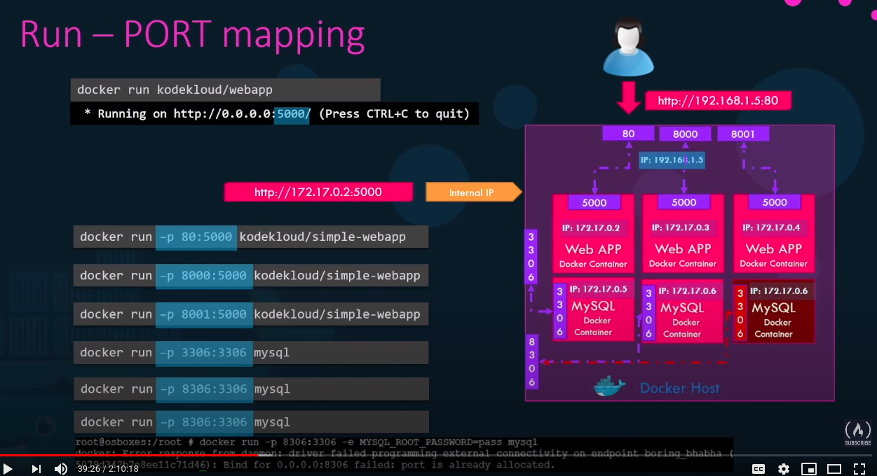

docker run -v opt/datadir:/var/lib/mysql mysql
mapping mysql inside container to data on host

docker inspect <container_name>
will return details in json

docker logs image_name

docker run -e APP_COLOR=blue <image>
this is environment variable

Creating image

docker build Dockerfile -t ajeetkumarv/my-app
docker push ajeetkumarv/my-app
to make it available on public repository

docker build .
docker build-t my-app .
Docker run my-app

Dockerfile template
INSTRUCTION ARGUMENT

Dockerfile Sample
FROM Ubuntu

RUN apt-get update
RUN apt-get install python

RUN pip install flask
RUN pip install flask-mysql

COPY . /opt/source-code

ENTRYPOINT FLASK_APP=/opt/source-code/app.py flast run

docker histroy <image>
to see the details how image was created

Example image name sleeper
FROM Ubuntu
CMD sleep 5

docker run sleeper sleep 10

FROM Ubuntu
ENTRYPOINT [“sleep”]

docker run sleeper 10

FROM Ubuntu
ENTRYPOINT [“sleep”]

CMD [“5”]

this makes 5 as default command

Replacing ENTRYPOINT while running
docker run –entrypoint sleep sleeper 10

By default container attaches to Bridge network
docker run ubuntu
docker run Ubuntu --network=none
docker run Ubuntu –network=host

Birdge is the private network created by docker on host
docker network ls
docker inspect <container_name>

containers resolve each other using their name
docker DNS ip is 127.0.0.11

Storage
/var/lib/docker
aufs
containers
image
volumes

Compose
docker-compose.yml
services:
web:
image: “my-app1”
database:
image: “mongodb”

docker run -d --name=redist redis

docker run -d –name=vote -p 5000:80 --link redis:redis voting-app

if using private registry
docker login private-registry.io
docker run private-registry.io/apps/internal-app

cgroups or control groups to control container access to resources
docker run –cpus=.5 ubuntu
max 50% of cpu
docker run --memory=100m ubuntu
100mb max

